**Name:- Kshitija Randive**

**Assignment 1: Linux Basics**

**1. Creating and Renaming Files/Directories**

Create a directory named test_dir using mkdir.

Inside test_dir, create an empty file called example.txt using touch.

Rename example.txt to renamed_example.txt using mv

**Ans:-**

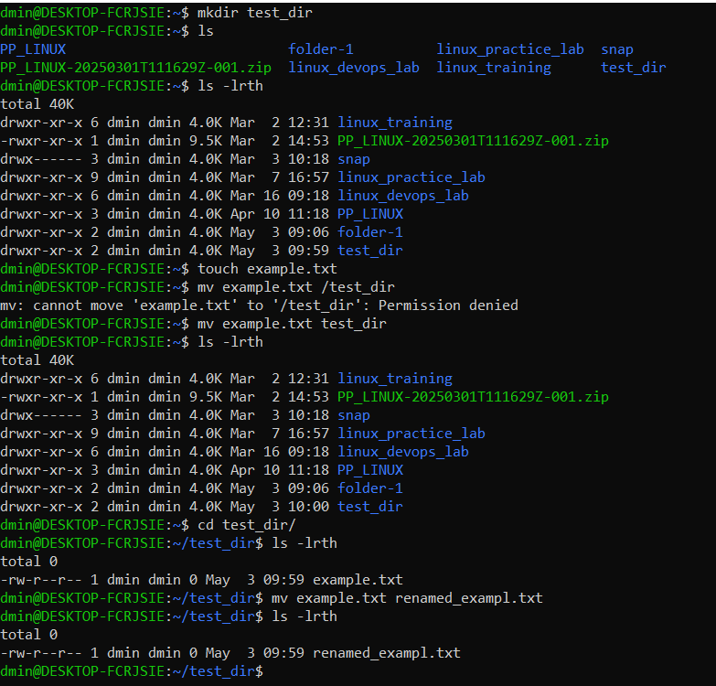

**2. Viewing File Contents**

Use cat to display the contents of /etc/passwd.

Display only the first 5 lines of /etc/passwd using head.

Display only the last 5 lines of /etc/passwd using tail.

**Ans:-**

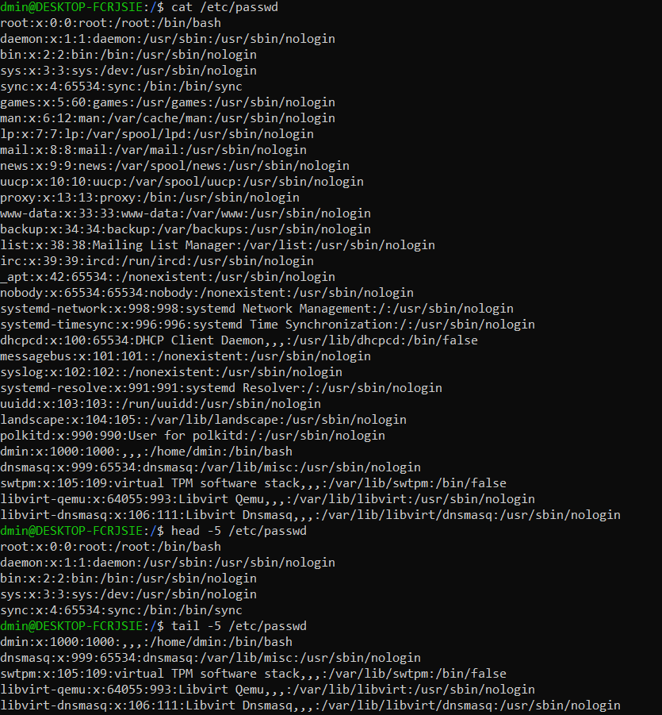

**3.Searching for Patterns**

Use grep to find all lines containing the word "root" in /etc/passwd.

**Ans:-**

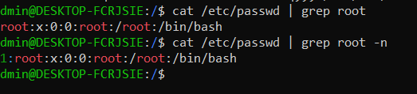

**4. Zipping and Unzipping**

Compress the test_dir directory into a file named test_dir.zip using zip.

Unzip test_dir.zip into a new directory named unzipped_dir.

**Ans:-** 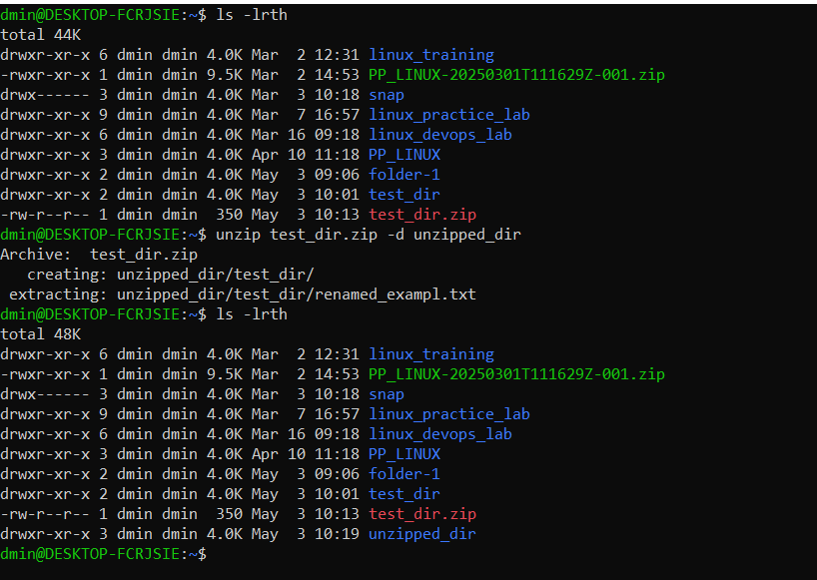

**5. Downloading Files**

Use wget to download a file from a URL (e.g., <https://example.com/sample.txt>).

**Ans:-**

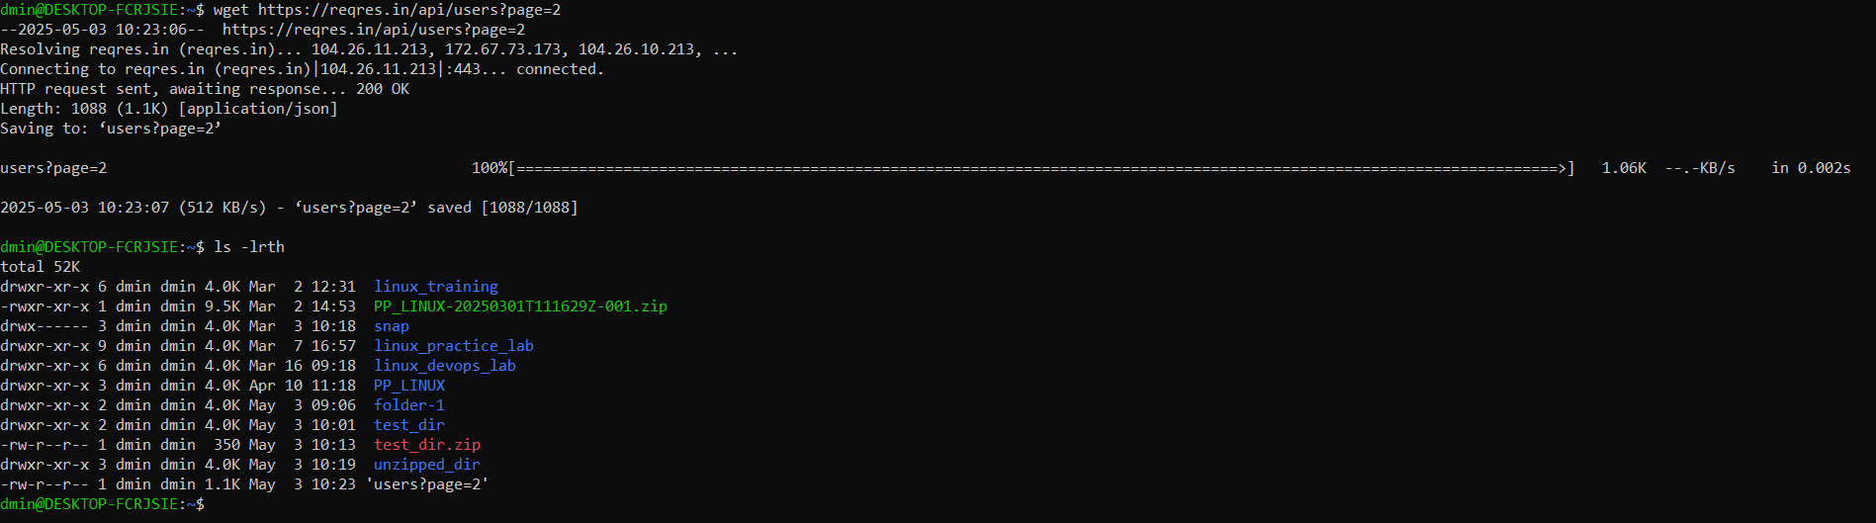

**6. Changing Permissions**

Create a file named secure.txt and change its permissions to read-only for everyone using chmod.

**Ans:-**

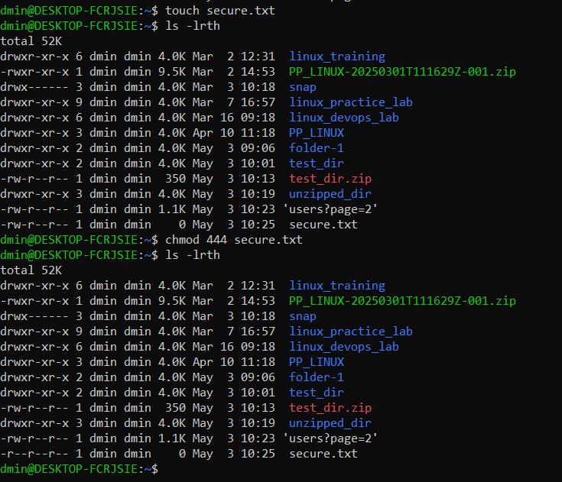

**7. Working with Environment Variables**

Use export to set a new environment variable called MY_VAR with the value "Hello, Linux!".

**Ans:-**

